Image | 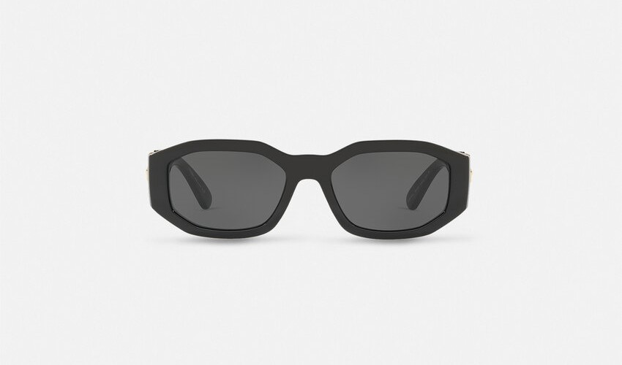
Brand | TOM FORD
Model Name | MEDUSA BIGGIE SUNGLASSES
Price | RS 125,300
PRODUCT DETAILS

